iStockphoto.com/Eliza Snow

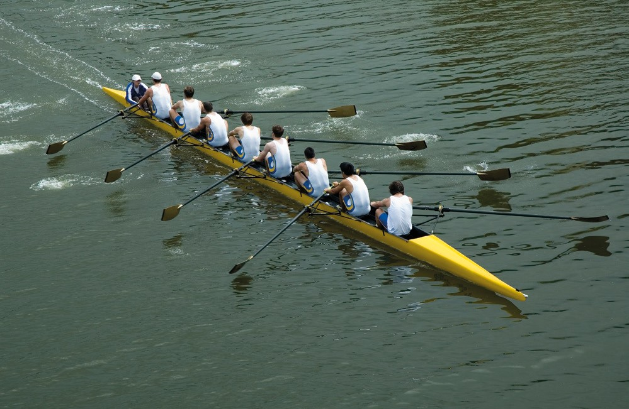

Developing movement skills

**Introduction**

the nature of movement skills types of movement skills

Fundamental versus specialised movement skills skill continuums

**Transferring movement skills** Positive transfer of movement skills negative transfer of movement skills

**Practice**

Qualities of effective practice Practice methods

mental practice and rehearsal

**The value of mastering skills**

Acquiring specialised movement skills

# Introduction

Movement skills are the tools that we use to participate in sports, games and general physical activities. Your level of movement skill can be measured by how efficiently you can complete a goal-directed movement task. Movement skills can be classified in many ways and are learnt most efficiently through quality practice.

## The nature of movement skills

Movement skills are actions that require body movement to achieve predetermined objectives. They can involve small movements, such as throwing a dart; large movements, such as a sprint run; or a combination of both, as in spin bowling in cricket. All movement skills are goal-directed and require practice to achieve proficiency. Skilled performers have excellent movement skills and make few errors. In the early stage of skill development, novice performers make frequent large errors and need to see the skill demonstrated effectively to help them learn. Movement skill performance can be improved with quality instruction, a supportive environment and opportunities to practice.

## Types of movement skills

One of the ways to classify movement skills is by how difficult they are to perform. In this way, skills are classified as either fundamental movement skills or specialised movement skills.

Another way to classify movement skills is by the type of movement they involve. Based on this classification, movement skills can be described as locomotor, non-locomotor or manipulative.

* **Locomotor movement skills** involve moving the body from one point to another. Some examples are running, swimming and cycling.
* **Non-locomotor movement skills** are performed while you are stationary, such as a static balance (for example, an arabesque or a stork stand), bend, sway and twist. Pivoting in basketball is also an example of a non-locomotor skill.
* **Manipulative movement skills** involve the control of a piece of equipment, such as a ball, bat or stick. Examples include bowling in cricket, striking in baseball and throwing a dart.

#### Understanding movement

1. Working with a partner, choose two popular sports and list the locomotor, non-locomotor and manipulative skills involved in each. Share your results with the rest of the class.

a

b

1. Educational gymnastics is a style of gymnastics that relies on the execution of movement skills to develop dynamic and entertaining routines.
   1. In pairs, develop a sequence consisting of at least 15 different movement skills. Use the space provided to record your ideas.
   2. Your teacher will provide the opportunity for you to practise your routine in order to make necessary changes and refine your performance.
   3. Once happy with your routine, you will perform it to the class. This will be followed by a discussion about what movement skills you incorporated into your routine.



## Fundamental versus specialised movement skills

Fundamental movement skills provide the foundation for participation in most major sports and games. These skills are less complicated movement skills and include locomotor, non-locomotor and manipulative skills. The sprint run, vertical jump, overarm throw, catch, two-handed strike and kick are all examples of fundamental movement skills.

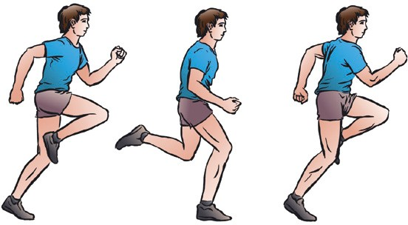

### Sprint run

Running is a locomotor skill used in many games, sports and physical activities. The key points of the sprint run are:

* head and chest held up to create erect posture
* body leaning slightly forward
* high knee lift as leg swings through
* arms and legs moving forward without sideward deviation
* elbows bent at 90°
* arms drive forward and back in opposition to legs.

### Vertical jump

*Running technique*

The vertical jump is a locomotor skill that forms the basis for jumps used in a variety of sports and activities, including athletics, gymnastics, basketball, netball, rugby and volleyball. The key points of the vertical jump are:

* eyes focused forward or upward throughout the jump
* crouched with knees bent and arms behind the body
* arms used to generate upward force
* legs straighten in the air as arms are thrust forward and upward
* land on the balls of the feet and bend knees to absorb impact
* controlled landing with no more than one step in any direction.

### Overarm throw

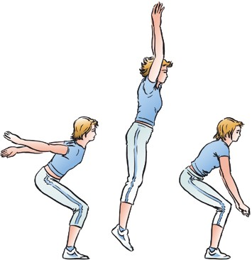

*Vertical jump technique*

The overarm throw is a manipulative skill used in cricket, softball, netball, basketball and many other sports. The key points of the overarm throw are:

* standing side-on to the target
* as the throwing arm is moved in a backswing, weight is shifted to the back foot
* throwing arm moves in a downward and backward arc
* step towards target with foot opposite the throwing arm
* hips and then shoulders rotate forward
* throwing arm follows through, down and across body.

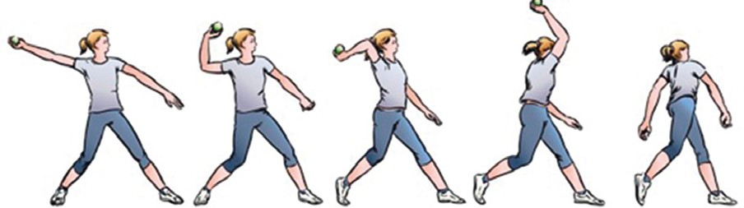

*Overarm throw technique*

### Catch

Catching is a manipulative skill used in cricket, softball, baseball, netball, rugby and basketball. The key points of the catch are:

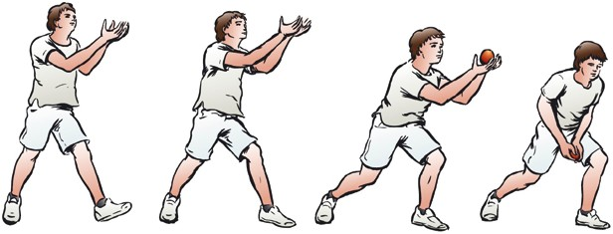

* + eyes focused on the object throughout the catch
  + feet move to place the body in line with or behind the object
  + hands and fingers relaxed and slightly cupped to catch the object without grabbing at it
  + object is caught cleanly with the hands only (no shoulders or chest involved)
  + elbows bend to absorb force as the

object makes contact with the hands. *Catching technique*

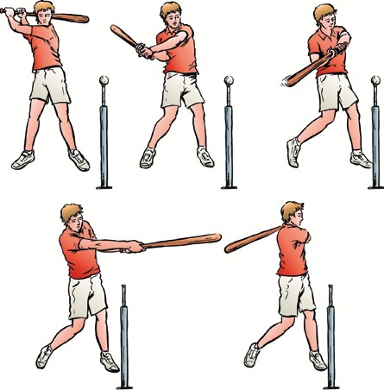

### Two-handed strike

The two-handed strike is a manipulative skill that forms the foundation of a number of advanced skills, including the drive in cricket, the strike in T-ball and baseball, the golf swing and the ground strokes in racquet sports. The key points of the two-handed strike are:

* + standing side-on to the target
  + eyes focused on the ball throughout the strike
  + hands next to each other on the bat, the bottom hand matches the front foot
  + step towards the target with the front foot
  + hips and then shoulders rotate forward
  + ball contact made on the front foot with straight arms
  + follow through with the bat around the body.

### Kick

*Two-handed strike technique*

The kick is a manipulative skill used in soccer, rugby and Australian Rules football. Although there are differences in the technique used for various sports, the key points for the stationary place kick are:

* + eyes focused on the ball throughout the kick
  + forward and sideward swing of the arm opposite to the kicking leg
  + non-kicking foot placed beside the ball, pointed towards the target
  + arms kept out to the side for balance
  + contact the ball with the top of the foot (shoelaces) or instep
  + kicking leg follows through high, towards the target area.

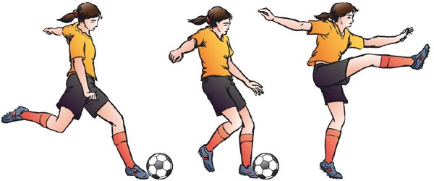

*Kicking technique*

#### Evaluating performance

1. Working in groups of four or five, use the key points from the six fundamental movement skills described (sprint run, vertical jump, overarm throw, catch, two-handed strike and kick) to evaluate the skill proficiency of your group members.
   1. Each student will demonstrate their best technique in relation to each of the FMS by completing the skill three times. One of these times must be in slow motion.
   2. Using the table provided, rate the performance of the respective skills of other students based on whether each of the components were performed correctly (1 = needs work, 2 = fair, 3 = good).

|  |  |  |  |  |
| --- | --- | --- | --- | --- |
|  | **Student 1:** | **Student 2:** | **Student 3:** | **Student 4:** |
| **Sprint run** |  |  |  |  |
| **Vertical jump** |  |  |  |  |
| **Overarm throw** |  |  |  |  |
| **Catch** |  |  |  |  |
| **Two-handed strike** |  |  |  |  |
| **Kick** |  |  |  |  |

* 1. Each group should choose the student who performed the best. These students are then filmed performing the skill. The class can view the performances and discuss the FMS and relevant technique.

1. a What common errors or weaknesses did participants display?

b Choose three of the faults you identified and write what feedback you could give the athlete to help them identify what needs to be improved and how they can alter their technique to refine their performance.

## Skill continuums

It can be difficult to classify movement skills because they have many characteristics that can change in different situations. Each skill can also be classified using a number of dimensions. These dimensions include: type of muscular involvement, continuity of the skill, environmental factors influencing performance, level of interaction with other competitors, and level of organisation. Each of these dimensions is a continuum, or a range. At each end of the continuum the dimensions are opposites (for example, open versus closed), while the middle represents a merging of the characteristics.

### Muscular involvement continuum

Gross motor skills involve large muscle movement, where the precision of movement is not as important to the successful execution of the skill; for example, running and jumping. Fine motor skills require motor control of the small muscles of the body to achieve the skill outcome. They generally involve hand–eye coordination and a high degree of precision; for example, writing and spin bowling.

Rifle shooting

Fine motor skills

Netball pass

Triple jump

Gross motor skills

*The muscular involvement continuum*

#### Reviewing muscular involvement skills

1. Which do you think is the more important type of motor skill, gross or fine? Why?
2. Choose a sport and identify the skills required in the game as either a fine motor or gross motor skill.

### Continuity continuum

Continuous motor skills have no distinct beginning or end points. The start and finish of the skill is determined by the performer or by an external force, but not by the task itself. For example, in swimming and running the performer’s movements are a continuous flow of actions. Serial skills comprise several discrete skills put together into a series; for example, triple jump. Discrete motor skills have distinct starting and finishing points; for example, pitching in softball is a discrete skill, because when the ball is released the skill is complete.

Swimming

Continuous motor skills

Triple jump

Serial motor skills

Basketball free throw

Discrete motor skills

*The continuity continuum*

#### Reviewing continuity skills

1. Is throwing a javelin a continuous, serial or discrete skill? Why?
2. Identify whether the activities or events are discrete, continuous or serial motor skills.

|  |  |  |  |
| --- | --- | --- | --- |
| **Event** | **Discrete** | **Continuous** | **Serial** |
| **2000 m (athletics)** |  |  |  |
| **Shot-put** |  |  |  |
| **Steeple chase** |  |  |  |
| **Chest pass (netball)** |  |  |  |
| **Rowing** |  |  |  |

### Environmental requirements continuum

Closed skills are performed in predictable environments where the performer determines when to start the action: for example, dart throwing, archery, tenpin bowling. Open skills are performed under conditions where the surrounding environment is unpredictable and constantly changing. There is less certainty about what to do and when to do it, with limited time to make decisions; for example, rugby, hockey, sailing and surfing.

Archery

Closed skills

Rugby lineout throw

Soccer tackle

Open skills

*The environmental requirements continuum*

#### Reviewing environmental requirement skills

1. How does the open–closed skill continuum relate to learning a new movement skill?
2. Is practising basketball goal shooting in a stadium a closed skill or an open skill? Why?
3. Using the example provided as a guide, choose five closed activities that can develop into open activities.

|  |  |
| --- | --- |
| **Closed activity** | **Open activity** |
| Chest passing to a partner 15 times during netball training. | Throwing a chest pass to a player during a game situation. |
|  |  |
|  |  |
|  |  |
|  |  |
|  |  |

### Interaction continuum

Individual skills are those performed in isolation without opposition or the cooperation of team-mates; for example, a high diver’s competitor cannot directly influence performance. Coactive skills are performed at the same time, but competitors cannot directly impact the performance of others. In a 50-metre breaststroke race a swimmer cannot physically prevent their opponent from achieving a good result, but they are competing at the same time. Interactive skills are those in which performance can be directly influenced by the opposition. For example, a point guard dribbling the ball in basketball must avoid having the ball stolen by the opposition.

High diving

50 metre breaststroke

Dribbling in basketball



Individual skills Coactive skills Interactive skills

*The interaction continuum*

#### Reviewing interaction skills

1. Is weight lifting an individual, coactive or interactive skill? Why?
2. Place the activities along the interaction continuum provided.
   * performing a gymnastics routine
   * running a marathon
   * shooting in netball
   * hitting a baseball.

Individual skills Coactive skills Interactive skills

1. Sports such as archery or darts, which require closed and individual skills, may not have the same physical complexities as an open or interactive skill; however they have their own challenges. Make a list of the factors that may influence an athlete performing sports requiring these skills.

### Organisation continuum

Most skills are comprised of a number of subcomponents. Low-organisation skills are comprised of fewer and less complex components; for example, swimming and running. High organisation skills involve closely integrated and difficult

subcomponents that need to be combined. A handspring from a vault in gymnastics is an example of a highly organised skill because it involves run-up, take-off, vault contact, rotation in the air and landing.

Sprint run

Triple jump

Handspring from vault



Low-organisation skills

*The organisation continuum*

#### Reviewing organisation skills

1. Is cycling a low- or a high-organisation skill? Why?

High-organisation skills



1. Choose one of the following sports and identify the characteristics of the major skills involved using the continuums discussed: soccer, indoor swimming, netball or shooting.

# Transferring movement skills

Skill transfer is the effect that the learning and performance of one movement skill has on the learning and performance of another. Proficiency in fundamental movement skills provides the foundation for many specialised skills and helps you learn skills more quickly.

## Positive transfer of movement skills

Positive skill transfer occurs when your proficiency in one movement skill is enhanced by your previous learning and experience in a similar movement skill. For example, the movement skills involved in surfing are similar to the movement skills involved in skateboarding and snowboarding. The positive transfer of movement skills will help you learn a new, similar skill more easily.

iStockphoto.com/Marco Coda

iStockphoto.com/BirdofPrey

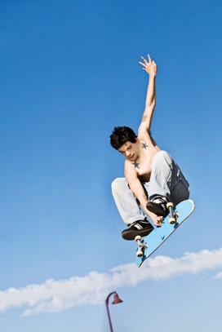

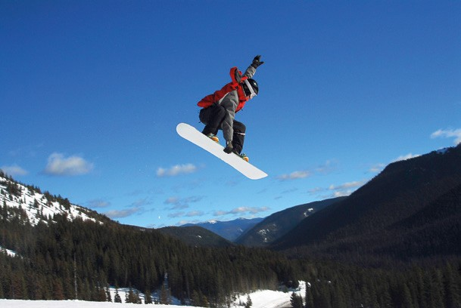

## Negative transfer of movement skills

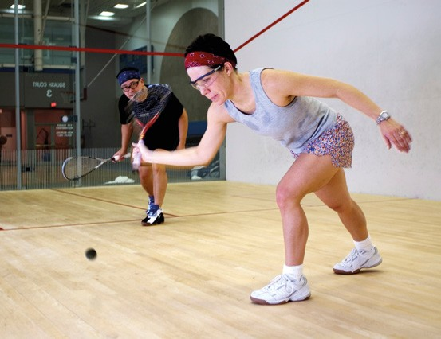

Negative skill transfer occurs when your ability to learn a new skill is impeded by your knowledge of and experience in a similar movement skill. This may occur when skills share some similarities but have important differences. For example, although the tennis and squash forehand strokes appear similar, the wrist action is very different. The tennis forehand requires a firm wrist, while the squash forehand requires flexible use of the wrist. Negative skill transfer will make it more difficult for an individual to learn a new skill.

iStockphoto.com/WebSubstance

iStockphoto.com/nycshooter

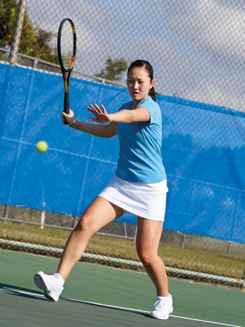

#### Understanding transferring movement skills

1 The overarm throw is a fundamental movement skill that can be transferred to a variety of specialised skills. Working in pairs, participate in the following skills:

* + volleyball overhead serve
  + javelin throw (using a soft javelin)
  + tennis smash
  + basketball overarm throw
  + tennis overhead serve
  + overarm throw using a tennis ball
  + badminton smash.

1. After completing the activities, discuss the common elements shared by all of the skills performed.
2. Consider the following specialised movement skills (you may wish to use video footage or clips from a YouTube or Google video to help you visualise the skills): tennis serve, volleyball overhead serve, rugby union tackle, rugby league tackle, javelin throw, ice hockey dribble, field hockey dribble and baseball pitch.
   1. Which of the skills might provide an example of positive skill transfer?
   2. Which of the skills might provide an example of negative skill transfer?
   3. Describe the possible consequences of negative skill transfer.
   4. Describe the benefits of positive skill transfer.
3. In pairs, discuss examples of your own experiences with positive and negative transference of skills.

# Practice

To learn and improve movement skills, you will need to practice. While traditional practice will require individuals to physically perform movement skills, skills can also be improved through mental rehearsal, which is another form of practice. It is recommended that you use a variety of practice techniques to develop movement skill proficiency.

## Qualities of effective practice

While individuals will develop movement skill proficiency at different rates, skill level can be increased through quality movement skill practice. The following qualities of effective practice have been identified to help people learn skills more efficiently.

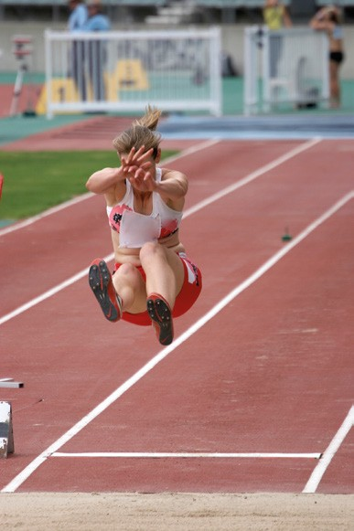

* ‘Practice with feedback, makes perfect.’ It is not enough for individuals to just receive the opportunity to practise; the emphasis should be on quality of movement. This can be achieved by focusing on technique rather than outcome. For example, someone learning how to shoot a free throw in basketball should focus on addressing the key points of the skill rather than the outcome of the shot—that is, whether or not the basketball went through the hoop.

Shutterstock.com/Nicholas Rjabow

* In all sports and physical activities the simplest skills should be learnt before the more complicated ones. The correct sequencing of skills can help to promote skill development, maintain individual motivation and prevent injury. For example, the skill sequence in volleyball is dig, set, serve, spike, block then dive.
* Complicated skills should be broken down into smaller parts when they are being learnt for the first time. For example, individuals learning the tennis serve for the first time should learn how to toss the ball correctly before attempting to complete the full serve.
* Pressure should be increased as skill proficiency improves. Once individuals become more confident performing skills, additional pressure should be added. The practice should progress from ‘closed’ to ‘open’ on the environmental requirements continuum, with gradual increases in skill performance and decision-making demands. For example, dribbling in hockey should be first learnt without any external pressure; as proficiency increases, the

task should become more difficult, with defenders introduced,

culminating in a game context.

## Practice methods

*In long jump, the run up, the take-off and the landing are each key skills.*

There are many types of practice that you can undertake to enable you to improve your performance. The most appropriate practice method will depend on a number of factors, including the amount of time available, the ability of the athletes, the equipment available and the type of skill to be learnt. Some practice methods are:

* **Massed practice** involves long, continuous practice sessions. Better initial results are achieved with massed practice but more injuries tend to occur because of mental and physical fatigue. Massed practice is suitable when the skill is simple, motivation for learning is high, and time available for practice is short.
* **Distributed practice** involves practice sessions that are spread out over a set time and are alternated with rest periods. Better long-term learning and skill retention is achieved with distributed practice. Distributed practice is useful when the skill to be learnt is new and complex, fatigue may lead to injury, attention spans are short and motivation is low.
* **Whole practice** involves practicing the skill in one complete sequence. Practicing the skill as a whole can help an athlete appreciate the complete movement and execution of the skill. This method is appropriate when the skill being learnt is simple and does not include multiple components or when the performer is at an advanced stage of skill development.
* **Part practice** breaks the task into distinct parts for individual practice. Once each part of the task is mastered, the skills are combined to form a whole. For example, the lay-up in basketball might be taught by breaking the skill down into the footwork and the shooting action. Part practice is useful when the skill being learnt is complicated and when the performer is in the early stages of skill development.

## Mental practice and rehearsal

Many athletes will use mental rehearsal to visualise themselves performing a skill before actually performing it. Combining mental and physical practice often gives improved results. The advantages of mental practice include increased confidence and the prevention of physical fatigue.

#### Learning through movement

Mental practice used in conjunction with positive self-talk is a positive and effective way to refine your skills.

1 Choose a skill from a sport that you play and practice visualising yourself performing it successfully.

Write a short dialogue outlining some positive self-talk phases or tips you could give yourself to enhance your visualisation practice and improve your performance.

Make sure to do it correctly

#### Reviewing practice

1. Debate the following topic as a class: ‘To what extent should a coach insist on the development of conventional technique?’ For example, if a young cricket bowler is generating speed and accuracy with an unusual action, should their technique be reconstructed?
2. Choose a sport and list an example of where each type of practice may be useful.

Sport: Basketball

Massed practice Trowing

Distributed practice

Whole practice playing games

Part practice

1. As a class, conduct a test of the effectiveness of each type of practice. a Divide the class into five groups.
2. Decide on a skill that everyone will learn such as a lacrosse throw, a basketball lay-up or juggling. c Allocate a type of practice to each group.
3. Devise a peer-assessment tool to assess the effectiveness of each type of fitness. Record your peer- assessment tool in the space provided.
4. Predict the results and give reasons for your predictions.
5. Have each group learn the skill using only their assigned type of practice and record the results.

Discuss the final results of each method as a class.

1. Did the predicted and final results match for each practice type? If not, can you think of any reasons why this might be?
2. Draw conclusions about the most appropriate practice method for learning the skill your class chose.

# The value of mastering skills

Research suggests that there is a window of opportunity for the development of fundamental movement skills. The first eight years of a child’s life are regarded as the ‘golden years’ for skill development, because this is the time during which new skills are learnt most easily. However, you do not automatically develop movement skills, instead they are learnt through quality instruction, a supportive environment and opportunities to practise. Research suggests that it takes between 240 and 600 minutes for the average child to become proficient in one fundamental movement skill.

## Acquiring specialised movement skills

You progress through a number of stages as you develop proficiency in new movement skills. This will occur for different people at different rates and some people may never reach the final stage. Characteristics of the three stages of skill acquisition are:

* + **Cognitive stage:** individual needs to learn about how to execute the task, frequent large errors are made, a great deal of feedback is required, individual needs to see the skill demonstrated correctly, performance is inconsistent.

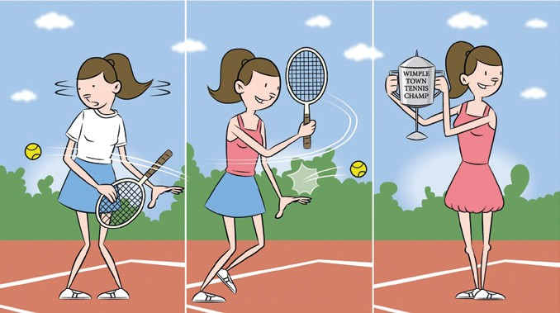

* + **Associative stage:** fewer errors are made, individual learns to detect and correct performance errors, individual relates to the correct technique, performance becomes more consistent.
  + **Autonomous stage:** automated performance of the skill, skill actions are highly refined, less emphasis on skill mechanics and more on tactics and strategies. Depending on the skill, this stage may be unachievable for most.

*You will get better at a movement skill as you move through its stages*

#### Understanding movement stages

1. What stage do you think a professional athlete would be at in their chosen sport, and in a sport they play for fun?

Autonomous for pro sport and Associative stage for lesser known sports

1. Describe how an individual moves through a number of stages as they learn and master a new skill.

As you get better the stage increases

1. Modified games are designed so that young players can concentrate on developing foundation skills of their required sport. List the modified sports that are available for children to play.
2. Choose one of the modified games and list the rule changes that are in place for young players and how each of these changes aid in their development of skills.
3. In groups of five, develop a modified version of a sport you are currently studying, so that your classmates have a greater opportunity to develop and refine their skills. Discuss your ideas as a class in order to come up with the final version of your game.

#### Fill in the gaps

|  |  |  |  |
| --- | --- | --- | --- |
| **closed skills** | **cognitive stage** | **fine motor skill** | **fundamental movement skills** |
| **gross motor skill** | **individual skills** | **massed practice** | **mental rehearsal** |
|  | **part practice** | **skill transfer** |  |

Fundamental Movement Skills are the building blocks for all types of games, physical activities and sports.Running is an example of a Gross Motor Skill because it involves large muscle groups. Writing requires greater precision and use of smaller muscles, and is therefore considered to be a Find Motor Skill.

Closed Skills are performed in predictable environments where the performer determines when to start the action.I ndividual skills are those performed in isolation without opposition or the cooperation of team-

mates. Skill transfer refers to the effect learning and performance of one movement skill has on the learning and performance of another movement skill.

Visualising the performance of a movement skill without physically performing the skill is known as Mental Rehersal. More injuries tend to occur with Massed Practise because of mental and physical fatigue.

Part Practise involves breaking a movement skill into smaller parts and then learning them. The

Cognitive practise is the first stage of skill acquisition and is often characterised by frequent errors.

#### Developing movement skills word search

Find the twelve words hidden in this word search relating to developing movement skills. The words can run forward, backward, diagonally and vertically.

|  |  |  |
| --- | --- | --- |
| **Movement** | **Practice** | **Skills** |
| **Sprint** | **Jump** | **Kick** |
| **Catch** | **Mental** | **Throw** |
| **Locomotor** | **Transferring** | **Interaction** |

|  |  |  |  |  |  |  |  |  |  |  |  |  |  |  |  |  |  |  |
| --- | --- | --- | --- | --- | --- | --- | --- | --- | --- | --- | --- | --- | --- | --- | --- | --- | --- | --- |
| I | N | T | R | O | D | I | C | R | I | O | N | T | W | F | G | M | O | H |
| E | A | L | T | H | E | D | I | U | O | A | T | I | O | N | A | N | D | P |
| E | V | A | M | O | V | E | M | E | N | T | L | U | E | S | R | E | L | A |
| T | I | N | G | E | D | I | S | L | I | K | O | W | O | P | E | R | K | G |
| I | N | G | I | C | N | R | N | T | H | R | E | M | R | O | D | I | T | N |
| H | U | C | K | S | X | T | S | L | I | K | E | A | O | C | A | B | N | I |
| C | H | A | V | S | C | F | A | D | F | U | C | N | I | C | A | N | N | R |
| T | G | O | V | K | B | A | C | L | U | T | P | S | T | A | O | E | R | R |
| A | T | O | L | I | E | V | E | L | I | T | T | E | R | E | E | L | I | E |
| C | H | E | M | L | M | A | V | C | I | O | L | N | T | A | A | N | D | F |
| L | A | U | E | L | R | A | E | W | O | P | D | S | I | O | S | D | Y | S |
| B | U | I | L | S | D | E | R | S | A | E | E | P | R | R | H | G | B | N |
| T | K | I | T | L | A | T | H | E | T | H | R | O | W | K | P | C | S | A |
| H | A | I | I | A | M | T | S | K | I | L | L | T | R | Y | I | S | G | R |
| T | O | T | C | E | R | I | C | K | Y | A | M | O | V | E | M | A | M | T |
| I | N | T | E | K | A | Z | C | B | N | I | M | P | M | U | J | V | L | O |
| A | C | B | X | V | N | F | E | G | Y | K | A | B | T | O | Z | Q | E | Y |
| Y | E | N | S | D | H | I | N | T | E | R | A | C | T | I | O | N | T | J |
| M | B | T | C | E | Y | M | D | E | N | K | R | L | R | V | X | E | H | I |